Hotel Revenue & Cancellation Intelligence


Hotel Revenue & Cancellation Intelligence is a data analytics project designed to explore hotel booking behavior, cancellation patterns and revenue performance. Using: Python, Bigquery and Tableau.
The project analyzes the factors that influence reservation cancellations, evaluates their estimated financial impact, and identifies the most profitable customer segments and market channels.
The main objective of this project is to provide actionable insights that can help hotel managers improve revenue management strategies, optimize operational planning, reduce potential revenue loss caused by cancellations, and support more informed business decisions.

Table of Contents

Introduction 3
1. Dataset Description and Source 4
2. Data Cleaning and Preparation: Using Python 6
2.1 Removing Duplicate Records 6
2.2 Handling Missing Values 7
2.3 Fixing Data Types 8
2.4 Standardizing Data Formats 8
2.5 Fixing Structural Errors 9
2.6 Handling Outliers 9
2.7 Consistency Checks 9
3. Analysis: Using BigQuery 10
4.1 KPI View 10
4.2 Cancellation Analysis View 11
4.3 Revenue Analysis View 14
4.4 Revenue Loss Analysis View 15
Conclusion of the Analysis Phase 19
4. Insights and Dashboard Interpretation: using Tableau 20
4.1 KPI 20
4.2 Cancellation Analysis Dashboard 21
4-3 Revenue analysis 26
4-3 Customer analysis 30
Conclusion and Recommandations 33

Introduction

The hospitality industry operates in a highly dynamic environment where booking behavior, customer preferences, and seasonal demand patterns directly influence hotel profitability. One of the most critical operational challenges faced by hotels is booking cancellations. Frequent cancellations create uncertainty in occupancy forecasting, reduce revenue stability, and negatively affect resource planning and operational efficiency.
This project, Hotel Revenue & Cancellation Intelligence, aims to analyze hotel booking data in order to understand the major factors behind reservation cancellations, evaluate their financial impact, identify the most profitable customer segments and markets, and explore seasonal booking behavior. Through data analysis and business intelligence techniques, the project aims to provide actionable insights help to hotel managers improve revenue management strategies and reduce unnecessary financial losses.
Why Do Cancellations Occur Frequently?
Hotel cancellations may occur due to several operational and customer-related factors. This project investigates whether cancellation behavior is influenced by variables such as:
- Lead Time:
Customers who book far in advance may be more likely of cancel because their travel plans can change over time.
- Customer Type:
Different customer categories (transient, contract, group, repeated guests) may demonstrate different cancellation behaviors.
- Deposit Type:
Reservations with refundable deposits or no deposits may be more likely to be canceled compared to non-refundable bookings.
- Market Segment:
Online travel agencies, corporate bookings, aviation groups, and direct bookings may show different cancellation patterns.
By identifying these relationships, hotels can better predict cancellations and implement targeted strategies to minimize them.
How Do Cancellations Affect Revenue?
Booking cancellations directly impact hotel revenue and occupancy planning. A canceled reservation represents not only lost income but also missed opportunities for selling rooms to other customers.
This project evaluates the financial impact of cancellations using several important metrics:
- Revenue Lost:
The estimated amount of revenue lost due to canceled reservations.
- Cancellation Rate:
The percentage of bookings that were canceled relative to total reservations.
Understanding these indicators helps hotel management assess the economic consequences of cancellations and optimize pricing and overbooking strategies.

What Are the Best Markets and Customer Segments?
Another major objective of this project is to identify the most valuable markets and customer groups. The analysis focuses on:
- The most profitable customer categories.
- Repeated guests and their contribution to business stability.
These insights can help hotels improve customer targeting, strengthen loyalty programs, and prioritize profitable market segments.

How Does Seasonal Demand Behave?
Hotel demand changes significantly throughout the year due to tourism seasons, holidays, and business travel trends. Therefore, analyzing seasonality is essential for effective hotel management.
This project examines:
- The months with the highest booking volumes.
- Seasonal demand trends across the year.
Understanding seasonal patterns allows hotels to optimize pricing, staffing, and marketing campaigns according to demand fluctuations.

1. Dataset Description and Source

The dataset used in this project was obtained from Kaggle:
Hotel Bookings Dataset on Kaggle
The dataset contains hotel booking information for both City hotels and Resort hotels, including customer demographics, reservation details, booking status, and revenue-related variables.
Dataset Overview
- Dataset Shape:
(119390, 32)
This means the dataset contains:
- 119,390 rows (hotel reservations)
- 32 columns (features and booking attributes)

Main Features Included in the Dataset
The dataset contains several important variables relevant to hotel operations and customer behavior, including:
Column | Description
Hotel | Type of hotel
is_canceled | Indicates whether the booking was canceled
lead_time | Number of days between booking and arrival
arrival_date_year | Arrival year
arrival_date_month | Arrival month
stays_in_weekend_nights | Weekend stay duration
stays_in_week_nights | Weekday stay duration
adults / children / babies | Number of guests
Country | Customer country
market_segment | Booking market segment
distribution_channel | Booking distribution channel
is_repeated_guest | Whether the customer is a repeated guest
previous_cancellations | Previous cancellations by the customer
deposit_type | Deposit category
customer_type | Customer classification
Adr | Average Daily Rate
reservation_status | Final reservation status

Data Types
The dataset contains multiple data types including:
- Categorical variables (object):
hotel, country, market_segment, deposit_type, customer_type, etc.
- Numerical variables (int64 / float64):
lead_time, adr, adults, booking_changes, previous_cancellations, etc.
- Date-related variables:
reservation_status_date
These mixed data types make the dataset suitable for both statistical analysis and predictive modeling.

Missing Values
Several columns contain missing values that require preprocessing before analysis:
Column | Missing Values
Children | 4
Country | 488
Agent | 16,340
Company | 112,593
The extremely high number of missing values in the company column indicates that most reservations were not associated with companies.

Duplicate Rows
The dataset contains a significant number of duplicated records:
- Duplicate Rows: 31,994
These duplicates were investigated carefully because the dataset does not include a unique booking identifier.

2. Data Cleaning and Preparation: Using Python

Data preprocessing is one of the most important stages in any data analysis project because raw datasets often contain inconsistencies, missing values, duplicates, and structural issues that may negatively affect analytical accuracy.
The following steps were performed to clean and prepare the dataset for analysis.

2.1 Removing Duplicate Records
Potential duplicate bookings were investigated manually because the dataset lacks a unique booking ID.
Detecting Duplicates
duplicate_count = df.duplicated().sum()

print("Duplicate Rows:", duplicate_count)
Output:
Duplicate Rows: 31994
Viewing Duplicate Samples
duplicates = df[df.duplicated(keep=False)]

duplicates.head(10)
Removing Duplicates
df = df.drop_duplicates()

print("\nShape After Removing Duplicates:", df.shape)
Removing duplicates helps ensure data consistency and prevents biased analytical results caused by repeated records.

2.2 Handling Missing Values
The dataset contains missing values in several columns:
children 4
country 488
agent 16340
company 112593
Filling Missing Values in children
Missing values in the children column were replaced with 0 because the absence of a value most likely indicates no children included in the reservation.
df['children'] = df['children'].fillna(0)

Filling Missing Values in country
Missing country values were replaced with "Unknown" to preserve the records while clearly identifying missing geographic information.
df['country'] = df['country'].fillna('Unknown')

Handling agent and company
The agent and company columns contain many missing values. These missing values were not removed because not all reservations are associated with travel agencies or companies.
Instead, these variables were interpreted as indicators of booking source type.
The two columns may later be transformed into a new feature such as:
- Agent
- Company
- Direct Customer
This approach preserves useful business information without introducing misleading imputations.

2.3 Fixing Data Types
Some columns required datatype adjustments to improve consistency and analytical usability.
Observed Issues
Column | Issue
is_canceled | Stored as object instead of numeric/binary
Children | Stored as float although it represents counts
agent/company | Stored as float because of missing values
reservation_status_date | Stored as object instead of datetime
Example Fixes
df['is_canceled'] = df['is_canceled'].astype(int)

df['children'] = df['children'].astype(int)

df['reservation_status_date'] = pd.to_datetime(df['reservation_status_date'])
Converting data into appropriate formats improves computational efficiency and analytical accuracy.

2.4 Standardizing Data Formats
To ensure consistency across the dataset:
- Categorical values were reviewed for spelling inconsistencies.
- Date formats were standardized.
- Numerical columns were validated to ensure correct ranges and logical values.
The following command was used to inspect unique values across columns:
for col in df.columns:
print(f"\nColumn: {col}")
print(df[col].unique())
This step helped identify inconsistent categories and structural anomalies.

2.5 Fixing Structural Errors
Structural issues such as inconsistent labels, invalid categories, or formatting mismatches were reviewed and corrected where necessary to improve dataset reliability.
Examples include:
- Ensuring consistent capitalization.
- Verifying valid categorical labels.
- Checking logical consistency between reservation status and cancellation indicators.

2.6 Handling Outliers
Outlier detection was performed on important numerical variables such as:
- adr
- lead_time
Extreme values were investigated to determine whether they represented legitimate business cases or abnormal entries.
Handling outliers helps improve the quality of statistical analysis and predictive modeling.

2.7 Consistency Checks
Final consistency checks were conducted to validate the integrity of the cleaned dataset, including:
- Verifying absence of duplicate rows.
- Confirming missing value handling.
- Ensuring valid data types.
- Checking logical consistency across related variables.
These preprocessing steps ensure that the dataset is reliable, structured, and ready for exploratory analysis and business intelligence modeling.

3. Analysis: Using BigQuery

After completing the data cleaning and preparation phase, the dataset was loaded into Google BigQuery to perform analytical processing and generate structured datasets for visualization and dashboard creation.
BigQuery was selected because it provides scalable cloud-based SQL analytics, fast query execution, and efficient handling of large datasets. Several analytical views were created to simplify business intelligence operations and support visualization tools such as Power BI or Tableau.
The analysis phase focused on six major business dimensions:
- KPI Overview
- Cancellation Analysis
- Revenue Analysis
- Customer Analysis
- Seasonality Analysis
Each view was designed to answer specific business questions related to hotel performance, customer behavior, cancellations, and revenue generation.

4.1 KPI View
The first analytical view was created to generate the main business KPIs (Key Performance Indicators) for the hotel booking system.
Objective
This view provides a high-level overview of hotel performance by calculating:
- Total bookings
- Total canceled bookings
- Cancellation rate
- Average Daily Rate (ADR)
- Total estimated revenue
- Average stay duration
These KPIs help management quickly evaluate the operational and financial health of the hotel business.

SQL Query
CREATE OR REPLACE VIEW
`project-e52c5edf-28c7-4932-8a2.hotel_analytics.booking_kpis`
AS

SELECT
COUNT(*) AS total_bookings,

SUM(is_canceled) AS canceled_bookings,

ROUND(
SUM(is_canceled) * 100.0 / COUNT(*),
2
) AS cancellation_rate,

ROUND(AVG(adr),2) AS avg_daily_rate,

ROUND(SUM(estimated_revenue),2) AS total_revenue,

ROUND(AVG(total_nights),2) AS avg_stay_duration

FROM
`project-e52c5edf-28c7-4932-8a2.hotel_analytics.hotel_bookings_cleaned`
Business Value
This KPI view acts as the foundation for the dashboard because it summarizes the most important business metrics in one place. It allows hotel managers to monitor overall performance and identify whether cancellation rates or revenue levels require further investigation.

4.2 Cancellation Analysis View
Understanding cancellation behavior is one of the most important goals of this project.
Objective
This view analyzes how cancellations vary according to:
- Hotel type
- Market segment
- Deposit type
- Customer type
- Booking source (agent/company)
- Lead time category
The analysis helps identify which booking conditions are most associated with high cancellation rates.

SQL Query
CREATE OR REPLACE VIEW
`project-e52c5edf-28c7-4932-8a2.hotel_analytics.cancellation_analysis`
AS

SELECT
hotel,

market_segment,

deposit_type,

customer_type,

agent_campany,

CASE
WHEN lead_time <= 30 THEN '0-30 Days'
WHEN lead_time <= 90 THEN '31-90 Days'
WHEN lead_time <= 180 THEN '91-180 Days'
WHEN lead_time <= 365 THEN '181-365 Days'
ELSE '365+ Days'
END AS lead_time_category,

COUNT(*) AS total_bookings,

SUM(is_canceled) AS canceled_bookings,

ROUND(
SUM(is_canceled) * 100.0 / COUNT(*),
2
) AS cancellation_rate,

ROUND(AVG(adr), 2) AS avg_adr,

ROUND(AVG(total_nights), 2) AS avg_stay_duration

FROM
`project-e52c5edf-28c7-4932-8a2.hotel_analytics.hotel_bookings_cleaned`

GROUP BY
hotel,
market_segment,
deposit_type,
customer_type,
agent_campany,
lead_time_category

Business Value
This analysis helps answer critical operational questions such as:
- Do longer lead times increase cancellation probability?
- Which market segments cancel the most?
- Are bookings without deposits more likely to be canceled?
- Which customer categories are the least reliable?
The results support better booking policies and revenue management strategies.

4.3 Revenue Analysis View
Revenue analysis focuses on understanding how revenue performance changes across time periods and customer segments.
Objective
This view calculates:
- Total bookings
- Estimated revenue
- Average ADR
- Average stay duration
Only successful (non-canceled) bookings were included to ensure accurate revenue calculations.

SQL Query
CREATE OR REPLACE VIEW
`project-e52c5edf-28c7-4932-8a2.hotel_analytics.revenue_analysis`
AS

SELECT
hotel,

arrival_date_year,

arrival_date_month,

market_segment,

customer_type,

COUNT(*) AS total_bookings,

ROUND(SUM(estimated_revenue), 2) AS estimated_revenue,

ROUND(AVG(adr), 2) AS avg_adr,

ROUND(AVG(total_nights), 2) AS avg_stay_duration

FROM
`project-e52c5edf-28c7-4932-8a2.hotel_analytics.hotel_bookings_cleaned`

WHERE is_canceled = 0

GROUP BY
hotel,
arrival_date_year,
arrival_date_month,
market_segment,
customer_type

4.4 Revenue Loss Analysis View
Managing cancellations is not only about counting lost bookings, but also about understanding their financial impact on hotel revenue.
Objective
This view measures the amount of revenue lost due to canceled bookings for each hotel type.
The analysis focuses on:
- Total estimated revenue generated by bookings
- Revenue lost from canceled reservations
- Percentage of revenue loss compared to total revenue
This helps evaluate how strongly cancellations affect the financial performance of each hotel.
SQL Query
CREATE OR REPLACE VIEW
`project-e52c5edf-28c7-4932-8a2.hotel_analytics.revenue_loss_analysis`
AS

SELECT
hotel,

ROUND(
SUM(estimated_revenue),
2
) AS total_revenue,

ROUND(
SUM(
CASE
WHEN is_canceled = 1
THEN estimated_revenue
ELSE 0
END
),
2
) AS lost_revenue,

ROUND(
(
SUM(
CASE
WHEN is_canceled = 1
THEN estimated_revenue
ELSE 0
END
) * 100.0
) / SUM(estimated_revenue),
2
) AS loss_rate

FROM
`project-e52c5edf-28c7-4932-8a2.hotel_analytics.hotel_bookings_cleaned`

GROUP BY
hotel
3.5 Customer Analysis View
Customer analysis focuses on identifying the most valuable and loyal customer groups.
Objective
This view examines:
- Country of origin
- Customer type
- Booking source
- Repeated guest behavior
It also measures:
- Total bookings
- Average ADR
- Estimated revenue
- Cancellation rate

SQL Query
CREATE OR REPLACE VIEW
`project-e52c5edf-28c7-4932-8a2.hotel_analytics.customer_analysis`
AS

SELECT
country,

customer_type,

agent_campany,

is_repeated_guest,

COUNT(*) AS total_bookings,

ROUND(AVG(adr), 2) AS avg_adr,

ROUND(SUM(estimated_revenue), 2) AS estimated_revenue,

ROUND(
SUM(is_canceled) * 100.0 / COUNT(*),
2
) AS cancellation_rate

FROM
`project-e52c5edf-28c7-4932-8a2.hotel_analytics.hotel_bookings_cleaned`

GROUP BY
country,
customer_type,
agent_campany,
is_repeated_guest

Conclusion of the Analysis Phase
The BigQuery analytical layer transformed the cleaned dataset into structured business views optimized for dashboard visualization and advanced analytics.
These views provide a comprehensive understanding of:
- Hotel performance
- Revenue generation
- Cancellation behavior
- Customer segmentation
- Seasonal demand
The generated analytical datasets serve as the foundation for the next phase of the project, which involves creating interactive dashboards and visual storytelling using business intelligence tools.

4. Insights and Dashboard Interpretation: using Tableau

After building the analytical views in BigQuery, the processed data was visualized using Tableau Public dashboards. The purpose of this phase was to transform raw analytical results into clear business insights that explain booking behavior, cancellation patterns, and customer dynamics.
The visualizations focused primarily on cancellation behavior and its relationship with lead time, customer categories, deposit types, and booking channels.

4.1 KPI
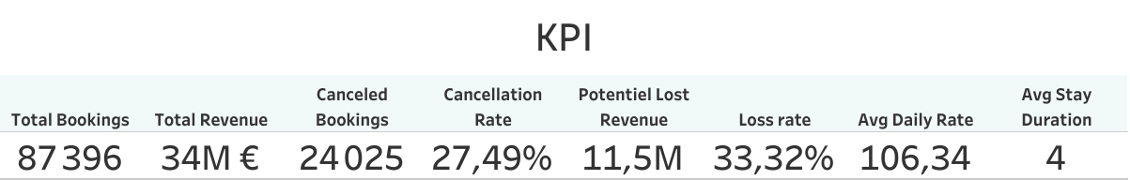

The KPI results reveal important insights into the hotel booking performance and the financial impact of cancellations.
A total of 87,396 bookings generated nearly 37 million in estimated revenue, reflecting strong business activity.
However, 24,025 bookings were canceled, leading to a cancellation rate of 27.49%. These cancellations represent a potential revenue loss of approximately 11.5 million, equivalent to 33.33% of total estimated revenue, highlighting a significant financial risk for the hotels.
In addition, the average daily rate (ADR) reached 106.34, while customers stayed an average of 4 nights per booking, indicating relatively stable booking value and stay duration.

4.2 Cancellation Analysis Dashboard
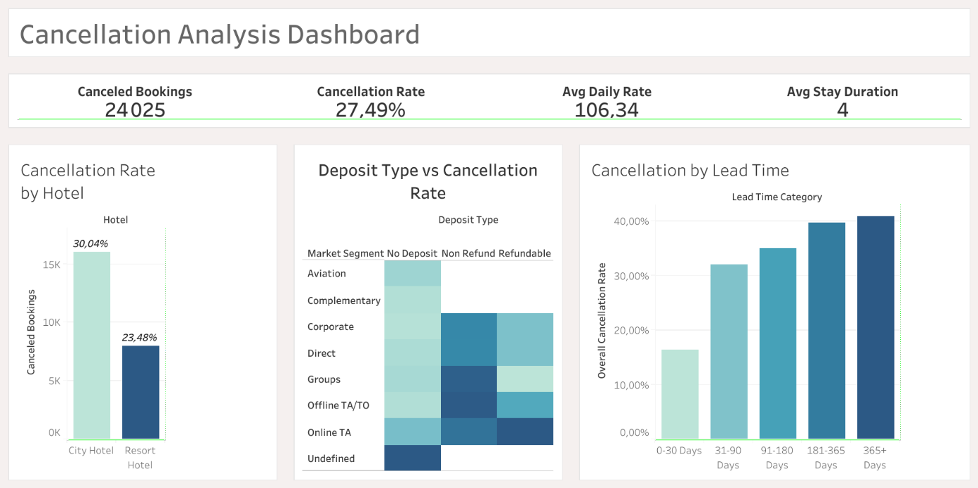
The first dashboard focused on understanding the major causes behind hotel reservation cancellations.

4.2.1 Lead Time Analysis
Business Question
Do customers who book far in advance cancel more frequently?
Insight
The dashboard indicates that reservations with very long lead times tend to experience significantly higher cancellation rates.
Customers who book several months before arrival are more likely to:
- Change their travel plans
- Modify schedules
- Cancel reservations due to uncertainty over time
The visualization suggests that long-term reservations represent a higher operational risk for hotels.

4.2.2 Customer Type Analysis
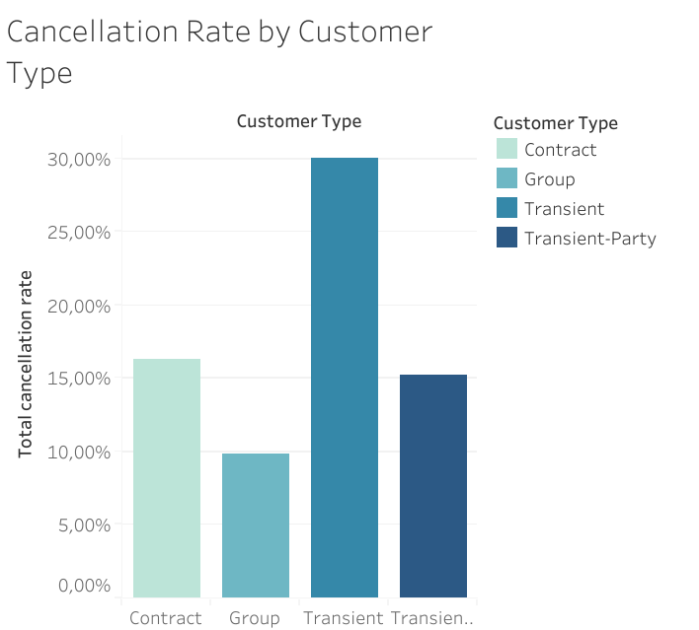
Business Question
Which customer category has the highest cancellation rate?

Insight
The dashboard revealed that Transient customers generated the highest number of cancellations.
However, the analysis also demonstrated an important analytical consideration:
Key Metrics
Customer Type | Canceled Bookings | Total Bookings | Cancellation Rate
Transient | 21,672 | 71,986 | 30.11%
Group | 54 | 544 | 9.93%
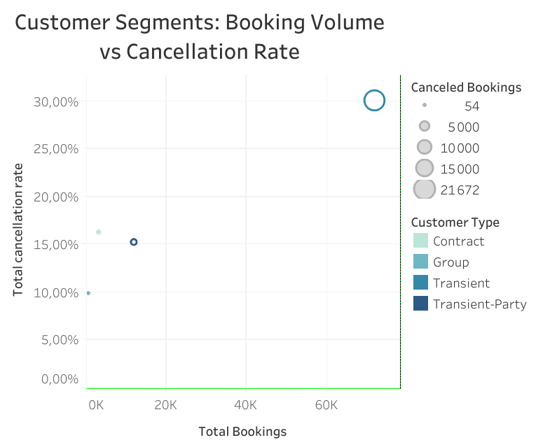
The high number of cancellations among transient customers is strongly influenced by the fact that this segment represents the largest share of total bookings.
Therefore, cancellation behavior should not be evaluated using cancellation counts alone, but rather relative to booking volume.

Business Interpretation
Although transient customers contribute heavily to hotel revenue, they also represent the most unstable booking category. Hotels may benefit from implementing:
- Flexible pricing strategies
- Deposit requirements
- Loyalty incentives
to reduce cancellations within this segment.
Meanwhile, group customers showed significantly lower cancellation rates, indicating greater booking stability.

4.2.3 Market Segment Analysis
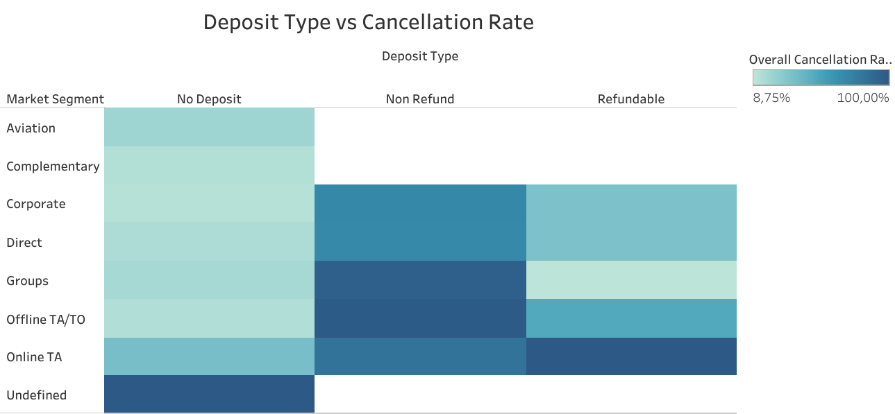
Business Question
Do different booking channels and market segments influence cancellation behavior?

Insight
The dashboard showed clear differences between booking channels and market segments.
The highest cancellation behavior was associated with:
- Online Travel Agencies (Online TA)
- Non-refundable booking structures
Meanwhile, corporate bookings showed relatively lower cancellation behavior.
Key Observation
Deposit Type | Market Segment | Cancellation Level
Non Refund | Online TA | High
No Deposit | Corporate | Low

Business Interpretation
At first glance, non-refundable bookings appeared to have the worst cancellation performance. However, deeper analysis suggests that the real driver behind cancellations is not only the deposit policy itself, but also:
- The type of customer
- The booking channel
- Customer booking behavior
This demonstrates the importance of combining multiple business variables rather than analyzing each factor independently.

4.2.4 Deposit Type Analysis
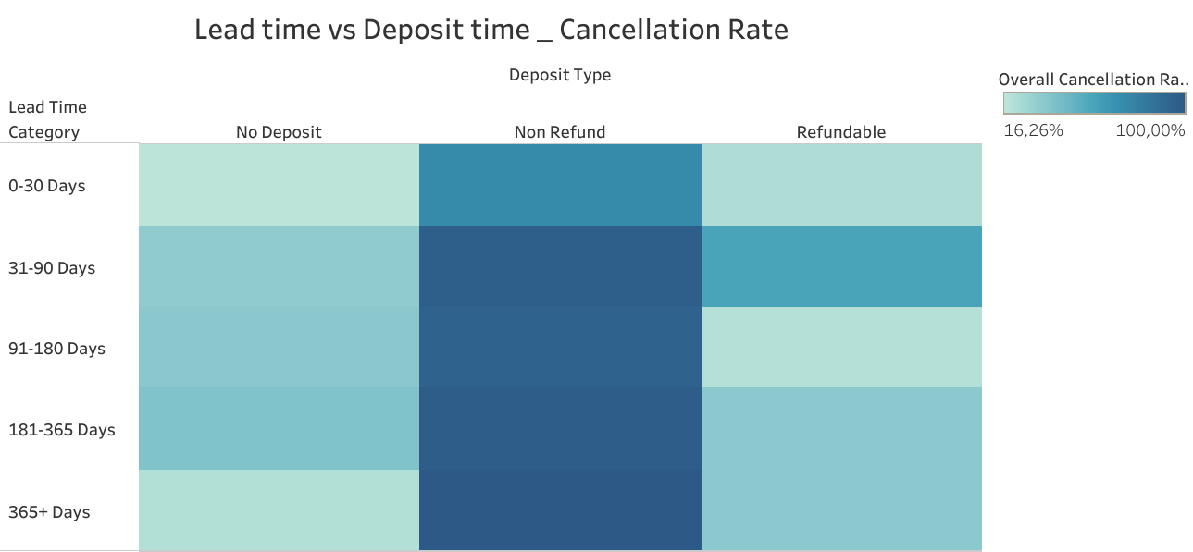
Business Question
Does deposit type affect cancellation probability?
Insight
The Deposit Type vs Lead Time chart suggests that reservations without strong financial commitment tend to cancel more frequently.
Bookings with:
- No deposit
- Refundable conditions
were associated with higher cancellation behavior compared to more restrictive reservation policies.
However, the analysis also revealed that deposit type alone is not sufficient to explain cancellations completely.
Cancellation behavior is strongly influenced by interactions between:
- Deposit type
- Lead time
- Market segment
- Customer type

Business Interpretation
Hotels should avoid relying solely on deposit policies when predicting cancellations. Instead, a combined risk model incorporating booking source, customer category, and booking timing would provide more accurate forecasting.

4-3 Revenue analysis

4-3-1 Dashboard: Hotel Revenue Performance & Seasonality Analysis
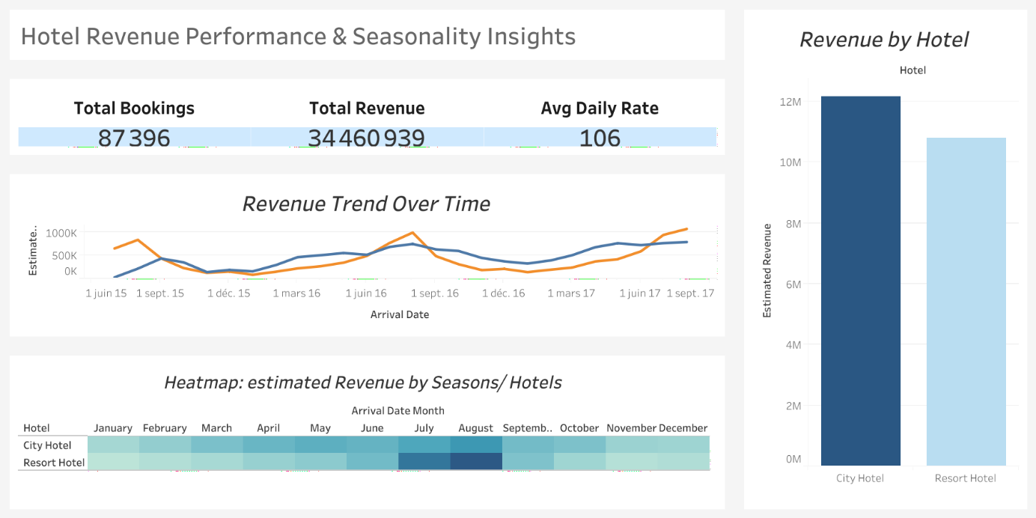
This dashboard analyzes hotel booking performance between 2015 and 2017, with a focus on revenue generation, seasonal demand patterns, and comparative hotel performance.

Executive Summary
The analysis reveals clear seasonal revenue patterns across both hotel types, with City Hotels generating higher total revenue overall, while Resort Hotels demonstrate stronger dependence on peak tourism seasons. Revenue trends also indicate consistent market growth over the analyzed period.

Key Insights
- City Hotels Generate Higher Overall Revenue
The analysis shows that City Hotels produced higher total revenue compared to Resort Hotels.
Interpretation
This suggests that City Hotels benefit from:
- More stable year-round demand
- Business travel activity
- Frequent short-term stays
- Urban tourism
Business Impact
City Hotels appear less vulnerable to seasonal fluctuations and provide more consistent financial performance.

- Strong Seasonal Revenue Peaks
Revenue trends display clear seasonal behavior, particularly during:
- July
- August
These months represent the highest revenue periods across the dataset.
Interpretation
Peak summer demand significantly increases hotel occupancy and revenue, especially for Resort Hotels.
Business Impact
Hotels should:
- Apply dynamic pricing strategies during peak seasons
- Increase operational capacity during high-demand periods
- Optimize staffing and resource allocation

- Resort Hotels Are Highly Seasonal
The heatmap and trend analysis reveal that Resort Hotels experience:
- Sharp revenue growth during summer months
- Significant declines during off-season periods
Meanwhile, City Hotels maintain relatively stable revenue throughout the year.
Interpretation
Resort Hotels rely heavily on:
- Leisure tourism
- Holiday travel
- Seasonal vacation demand
Business Impact
Resort Hotels may benefit from:
- Off-season promotional campaigns
- Discount packages
- Targeted seasonal marketing strategies

- Revenue Increased Between 2015 and 2017
The revenue trend indicates overall growth across the three-year period.
Interpretation
This may reflect:
- Increasing booking demand
- Improved occupancy rates
- Stronger market performance
Business Impact
The hotel industry within the dataset demonstrates positive long-term growth potential.

4-3-2. Average Daily Rate (ADR) Remained Strong
The average daily rate reached approximately:
- €106 per booking
The average stay duration was:
- 4 nights
Interpretation
Revenue growth appears to be driven more by:
- Booking volume
than by:
- Longer stays
Business Impact
Hotels may achieve better performance by maximizing occupancy and booking frequency rather than focusing solely on extended stays.

Recommendations
Based on the analysis, hotels should consider:
- Implementing dynamic seasonal pricing
- Expanding summer operational capacity
- Developing off-season marketing campaigns
- Monitoring revenue seasonality closely
- Focusing on high-performing booking segments
- Improving forecasting during peak tourism periods

4-3-2 Lost Revenue
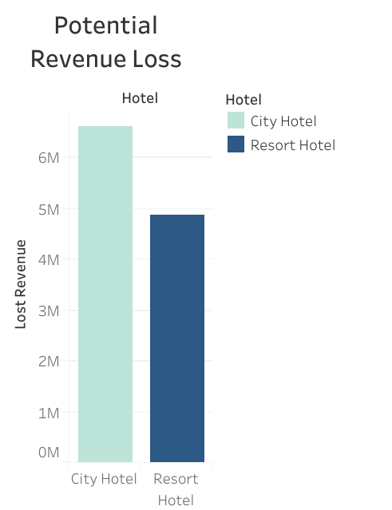
The revenue loss analysis highlights the significant financial impact of booking cancellations on both hotel types. Although both hotels generated strong estimated revenues, a substantial portion of this revenue remained at risk due to canceled reservations. The City Hotel experienced the highest estimated revenue loss, with more than 6.6 million in potentially lost revenue, representing 35.23% of its total estimated revenue.
Meanwhile, the Resort Hotel recorded an estimated loss of approximately 4.87 million, corresponding to 31.04% of total revenue. These results emphasize the importance of focusing on cancellation management strategies, as a large share of projected revenue may never be realized due to booking cancellations.
Hotel | Total Estimated Revenue | Estimated Lost Revenue | Loss Rate
Resort Hotel | 15.69M | 4.87M | 31.04%
City Hotel | 18.77M | 6.61M | 35.23%

4-3 Customer analysis

4-3-1 Dashboard: Hotel Revenue Performance & Seasonality Analysis
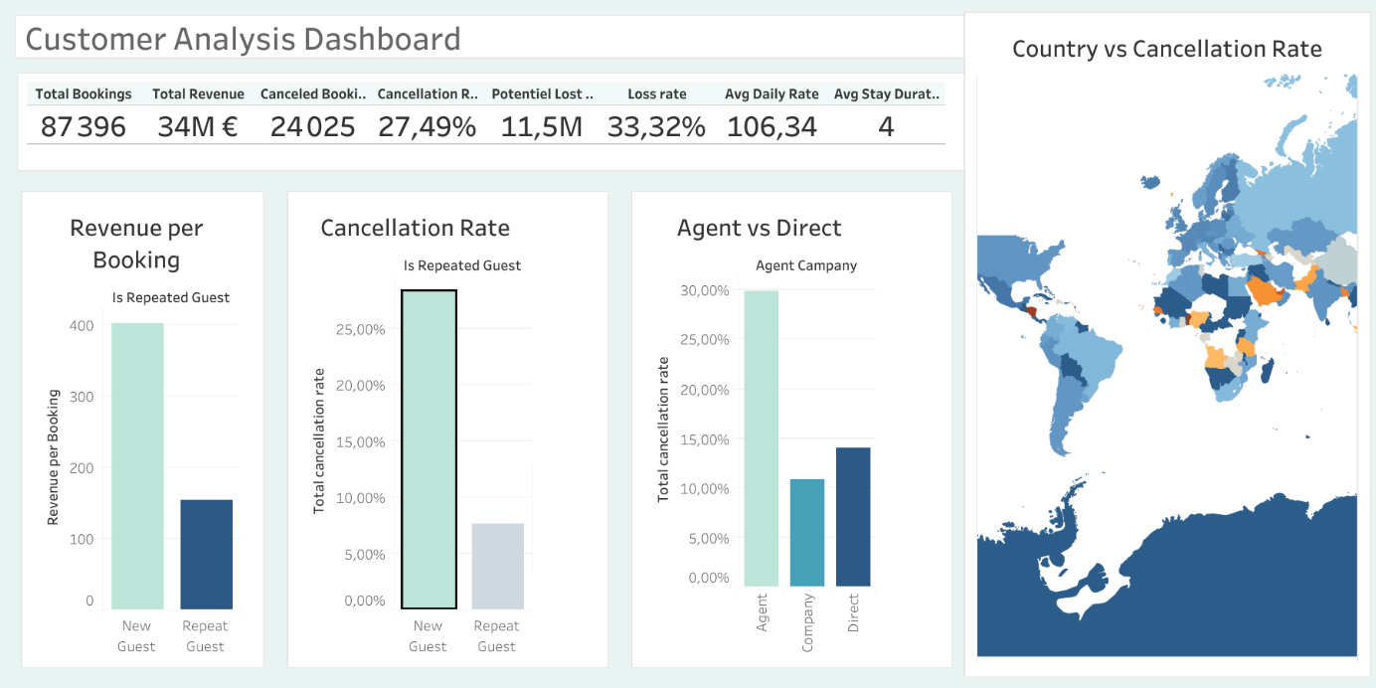
The Customer Analysis dashboard focused on several important dimensions, including:
- Repeated guests
- Revenue per booking
- Booking source (Agent vs Company)
- Country-based cancellation behavior
The purpose of this analysis was to identify the most valuable customer segments and understand which customer categories represent higher operational risks.

4.4.1 Repeated Guests and Cancellation Behavior
Business Question
Do repeated guests cancel less frequently than new customers?

The dashboard indicates that repeated guests demonstrate significantly more stable booking behavior compared to non-repeated guests.
Customers who previously stayed at the hotel tend to:
- Show greater booking commitment
- Cancel less frequently
- Contribute to operational stability
This behavior suggests that customer familiarity and loyalty reduce reservation uncertainty.

Business Interpretation
Repeated guests represent a highly valuable customer segment because they provide:
- More predictable occupancy
- Lower cancellation risk
- Stronger long-term customer relationships
Hotels should therefore prioritize loyalty programs and retention strategies to encourage repeat visits.

4.4.2 Revenue per Booking for Repeated Guests
Business Question
Do repeated guests generate higher revenue per reservation?
The visualization suggests that repeated guests generate stronger revenue performance per booking compared to many first-time customers.
This may result from:
- Longer stays
- Higher trust in hotel services
- Greater willingness to spend on premium accommodations
Repeated guests therefore contribute not only to booking stability but also to revenue quality.

Business Interpretation
Investing in customer retention may be more profitable than focusing entirely on acquiring new customers. Repeat customers provide both financial consistency and reduced operational risk.
Hotels can improve profitability by:
- Offering personalized promotions
- Providing loyalty rewards
- Enhancing customer experience for returning guests

4.4.3 Agent vs Company Booking Analysis
Business Question
How do booking sources influence cancellation behavior?
The dashboard compares reservations made through:
- Travel agents
- Companies/corporate channels
The analysis indicates that cancellation behavior differs significantly depending on booking source.
Agent-based reservations appear to demonstrate higher cancellation activity compared to company bookings.
This may be explained by:
- Flexible travel planning
- Larger booking volumes
- Online booking behavior
Meanwhile, company bookings appear more stable due to structured business travel arrangements.

Business Interpretation
Hotels should evaluate booking channels separately because each channel carries different levels of cancellation risk.
Corporate channels may provide:
- More reliable occupancy
- Lower cancellation rates
- Better long-term forecasting stability
Travel agency channels, while important for volume generation, may require stricter cancellation management policies.

4.4.4 Cancellation Rate by Country
Business Question
Do customer cancellation behaviors differ by country?
The dashboard reveals that cancellation behavior varies considerably across countries.
An important observation from the visualization is that:
Some countries demonstrate:
- Low reservation counts
- Very high cancellation rates
This means that cancellation risk cannot be evaluated only based on customer volume.
Certain geographic markets may generate unstable demand despite relatively small booking numbers.

Business Interpretation
Hotels should evaluate international markets not only according to booking quantity but also according to booking reliability.
Markets with consistently high cancellation behavior may require:
- Stricter reservation conditions
- Deposit requirements
- More accurate forecasting models
Meanwhile, countries with lower cancellation behavior may represent more reliable long-term target markets.

Conclusion and Recommendations

This project successfully analyzed hotel booking behavior, cancellation patterns, and revenue performance using Python, BigQuery, and Tableau. The analysis demonstrated that booking cancellations represent one of the most significant operational and financial challenges in the hospitality industry. Out of more than 87,000 bookings, approximately 27.5% were canceled, resulting in an estimated revenue loss exceeding €11 million.
The findings revealed that cancellation behavior is strongly influenced by several interconnected factors, including lead time, customer type, market segment, booking channel, and deposit policy. Customers who booked far in advance were significantly more likely to cancel, while repeated guests showed more stable and reliable booking behavior.
The analysis also highlighted major differences between hotel types. City Hotels generated higher overall revenue and maintained more stable demand throughout the year, whereas Resort Hotels were highly dependent on seasonal tourism demand, especially during summer months.
Furthermore, the project demonstrated that customer retention plays a critical role in improving financial stability. Repeated guests not only canceled less frequently but also generated higher-quality revenue and more predictable occupancy patterns.
Overall, the project proved the value of combining data analytics, cloud-based SQL processing, and business intelligence visualization to support hotel decision-making. The generated insights can help hotel managers improve forecasting accuracy, optimize pricing strategies, reduce revenue loss, and strengthen long-term profitability.

Recommendations
Based on the analytical findings, the following recommendations are proposed:
1. Implement Smarter Cancellation Risk Management
Hotels should develop predictive cancellation models that combine:
- Lead time
- Deposit type
- Customer category
- Booking channel
- Market segment
Using multiple variables together will improve cancellation forecasting accuracy more effectively than relying on single indicators alone.
2. Apply Dynamic Deposit Policies
Reservations with long lead times and high-risk booking channels should require stricter deposit conditions or partial prepayments. Flexible cancellation policies may still be offered to low-risk customer segments such as corporate and repeated guests.
3. Strengthen Loyalty Programs
Repeated guests demonstrated lower cancellation rates and stronger revenue contribution. Hotels should therefore:
- Offer loyalty rewards
- Create personalized promotions
- Improve customer experience
- Encourage repeat bookings
Customer retention can provide greater long-term value than focusing only on acquiring new customers.
4. Optimize Online Travel Agency (OTA) Management
Online Travel Agencies generated high booking volumes but also showed elevated cancellation behavior. Hotels should:
- Monitor OTA cancellation trends closely
- Introduce stricter booking conditions during peak periods
- Encourage more direct bookings through official hotel channels
5. Improve Seasonal Revenue Strategies
Because Resort Hotels are highly seasonal, hotels should:
- Apply dynamic pricing during high-demand months
- Launch off-season promotional campaigns
- Adjust staffing and operational capacity according to demand patterns
- Improve forecasting during tourism peaks

